using System.IO;

DEBE TENER PERMISOS DE LECTURA Y ESCRITURA EN EL DIRECTORIO

Busque documento en maquina local y guardelo en directorio wwwroot\loss_prevention\Investigation

- OPCION WEB

DESCARGAR DOCUMENTO EN LOCALIZACION

public const string Documentos = @"C:\Inetpub\wwwroot\loss_prevention\Investigation\";

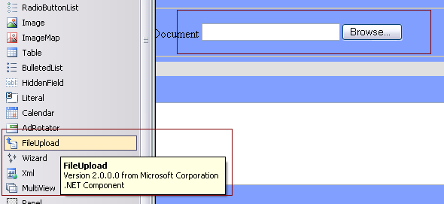

Attachment.Text = FileUpload1.FileName;
if (Attachment.Text.Length > 2)
{
Attachment.Text = Label1.Text + "_" + Attachment.Text;
string destiny = Generales.Documentos + Attachment.Text;
FileUpload1.SaveAs(destiny);
}

CARGAR DOCUMENTO

public const string Documentos = "C:\\Inetpub\\wwwroot\\loss_prevention\\Documents\\";

string archivo = Attachment.Text;
int posi = archivo.IndexOf(".");
string extension = archivo.Substring(posi+1, 3);

Response.ContentType = "application/msword";
if (extension == "doc") Response.ContentType = "application/msword";
if (extension == "pdf") Response.ContentType = "application/pdf";
if (extension == "xls") Response.ContentType = "application/vnd.ms-excel";
if (extension == "xls") Response.ContentType = "application/rtf";

Response.ContentType = "application/msword";
Response.AddHeader("Content-Disposition", "attachment");
Response.WriteFile(Generales.Documentos+Attachment.Text);

- OPCION CLIENT
DESCARGAR
Liste todos los archivos .doc en el directorio C:\\
y presente los documentos .doc en un tree
DirectoryInfo dirCustom = new DirectoryInfo("C:\\");

FileInfo[] filCustom;

filCustom = dirCustom.GetFiles(“*.doc”);

public void PopulateTree(string dir, TreeNode node) {
// get the information of the directory
DirectoryInfo directory = new DirectoryInfo(dir);
// loop through each subdirectory
foreach(DirectoryInfo d in directory.GetDirectories()) {
// create a new node
TreeNode t = new TreeNode(d.Name);
// populate the new node recursively
PopulateTree(d.FullName, t);
node.Nodes.Add(t); // add the node to the "master" node
}

// lastly, loop through each file in the directory, and add these as nodes
foreach(FileInfo f in directory.GetFiles()) {

// create a new node
TreeNode t = new TreeNode(f.Name);

// add it to the "master"
node.Nodes.Add(t);
}
}

Copia de archive de source a target
- public class SimpleFileCopy
- {
- static void Main()
- {
- string fileName = "test.txt";
- string sourcePath = @"C:\Users\Public\TestFolder";
- string targetPath = @"C:\Users\Public\TestFolder\SubDir";

- // Use Path class to manipulate file and directory paths.
- string sourceFile = System.IO.Path.Combine(sourcePath, fileName);
- string destFile = System.IO.Path.Combine(targetPath, fileName);

- // To copy a folder's contents to a new location:
- // Create a new target folder, if necessary.
- if (!System.IO.Directory.Exists(targetPath))
- {
- System.IO.Directory.CreateDirectory(targetPath);
- }

- // To copy a file to another location and
- // overwrite the destination file if it already exists.
- System.IO.File.Copy(sourceFile, destFile, true);

- // To copy all the files in one directory to another directory.
- // Get the files in the source folder. (To recursively iterate through
- // all subfolders under the current directory, see
- // "How to: Iterate Through a Directory Tree.")
- // Note: Check for target path was performed previously
- // in this code example.
- if (System.IO.Directory.Exists(sourcePath))
- {
- string[] files = System.IO.Directory.GetFiles(sourcePath);

- // Copy the files and overwrite destination files if they already exist.
- foreach (string s in files)
- {
- // Use static Path methods to extract only the file name from the path.
- fileName = System.IO.Path.GetFileName(s);
- destFile = System.IO.Path.Combine(targetPath, fileName);
- System.IO.File.Copy(s, destFile, true);
- }
- }
- else
- {
- Console.WriteLine("Source path does not exist!");
- }

- // Keep console window open in debug mode.
- Console.WriteLine("Press any key to exit.");
- Console.ReadKey();
- }
- }

If File.Exists(sourceFile) Then
File.Copy(sourceFile, newFile)
Else
Console.WriteLine("Source file does not exist.")
End If

